**Ref:** LoE/EQ/2025/02 **Date:** 04-02-2025

To,

Name : Ankur Kaushal

Enrolment No.: 210C2030218

Programme : B. Tech CSE

Mob. : 9784490753

E-mail :  ankur.kaushal.21cse@bmu.edu.in

**Letter of Engagement**

**Dear Ankur Kaushal,**

Greetings from ***BML Munjal University!*** Please refer to your application and our further discussion regarding your engagement with university under the provisions of the **“Earn While You Learn”** as a participating team member of the **Education Quality (EQ)** from ***5 February 2025 to March 2025.***

BML Munjal University strongly believes that skills and experience you will gain during this period of work-study engagement will be transferable to your eventual work-study engagement or other settings of professional pursuits and participation in other activities that supports the institutes overall mission will be highly appreciated during your tenure of participation.

As per the aforesaid policy, you will be entitled for a stipend of **Rs. 15000/-** for successfully developing, testing and deploying the project on **Course File Generator before March end 2025 for Education Quality.**

The work related to EQ office is of highly confidential in nature hence you need to sign a non-disclosure agreement, which is attached herewith marked as **Annexure – I**.

Please provide us with your banking details for payments and our compliance. **(Annexure-II)**

**Best wishes,**

**Dean - Education Quality**

**Annexure – I**

**Agreement with respect to Intellectual Property Rights, Moral Rights, Proprietary Information and Confidentiality Agreement**

I, Mr. Ankur Kaushal S/o.  Ramkripal Kaushal has been engaged with BML Munjal University under the provisions of the **“Earn While You Learn”** as a participating team member of the **Education Quality** from ***5 February 2025 to March 2025.***

In consideration of my engagement with BML Munjal University I agree as follows:

**Intellectual Property Rights and Moral Rights**

I hereby irrevocably assign to BML Munjal University all inventions that

* Are developed using the resources (in any form) of BML Munjal University.
* Result from work performed by me for BML Munjal University.
* Relate to BML Munjal University business, research & development (current and anticipated).

I hereby

* Irrevocably transfer and assign to BML Munjal University all Intellectual Property Rights and Moral Rights of any invention.
* Forever waive and agree never to assert any moral Right with respect to any invention.
* Acknowledge that all copyrightable works prepared by me within the scope of my employment with BML Munjal University are company property and BML Munjal University will be considered the author thereof.

My obligation with respect to the above will continue beyond the termination of my engagement with BML Munjal University.

**Proprietary Information**

I agree that my engagement with BML Munjal University creates a relationship of confidence and trust with respect to any proprietary information.

I agree to hold such Proprietary information in strict confidence and trust and will not disclose the same to any other party during my engagement and even after cessation of my engagement unless I have written approval from BML Munjal University.

I agree that I will not take with me any documents or materials or copies thereof containing any proprietary information.

**Maintaining Confidentiality**

I agree to maintain in strict confidence any information about BML Edu corp Services which I am privy to as a result of my employment and also information relating to the company’s customers which I become privy to when deputed to work from company’s customer.

**Reaffirmation**

I fully understand the implication of this agreement and the terms used therein and I acknowledge that in the event of a breach or threatened breach of this agreement by me, BML Munjal University is free to proceed with legal action or other equitable relief to enforce this agreement.

This agreement will be effective from the day my engagement started with BML Munjal University.

**Intern: For BML Munjal University**

Name : Ankur Kaushal Name _________________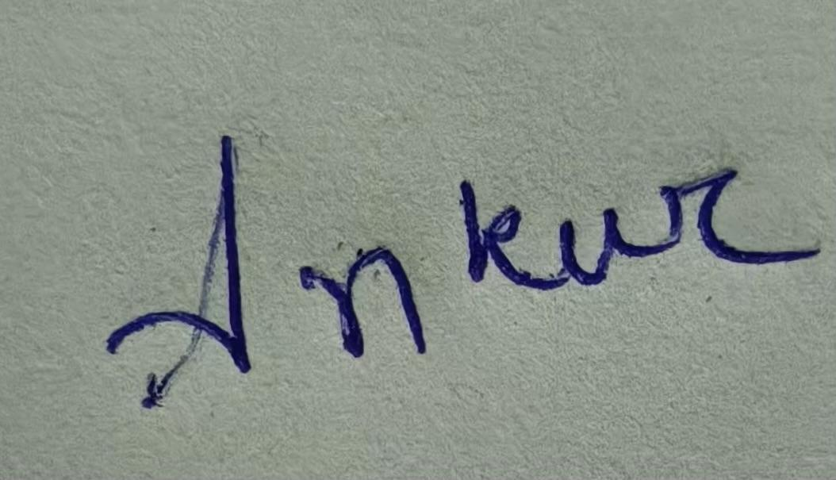

Signature: Signature _______________

Date 04/14/2025 Date__________________

**Annexure- II**

**BML MUNJAL UNIVERSITY**

**Earn While You Learn (EWYL) Form**

**Name: Date:**

I accept this internship opportunity and attach are the documents for processing my stipend, which may be credited to the following bank accounts-

* **Beneficiary Name: Ankur Kaushal**
* **Beneficiary Bank Name: Federal Bank**
* **Bank A/c Number: 5555 0124 7449 11**
* **Bank IFSC Code: FDRL0005555**
* **Bank Branch Address: Epifi Federal Neo Banking**

**Attachments to be submitted with this form:**

* PAN Card Copy
* PAN and Aadhar link Confirmation
* Copy of Cancelled Cheque
* Permanent Address Proof  
    
    
    
    
    
    
    
    
   **PAN CARD**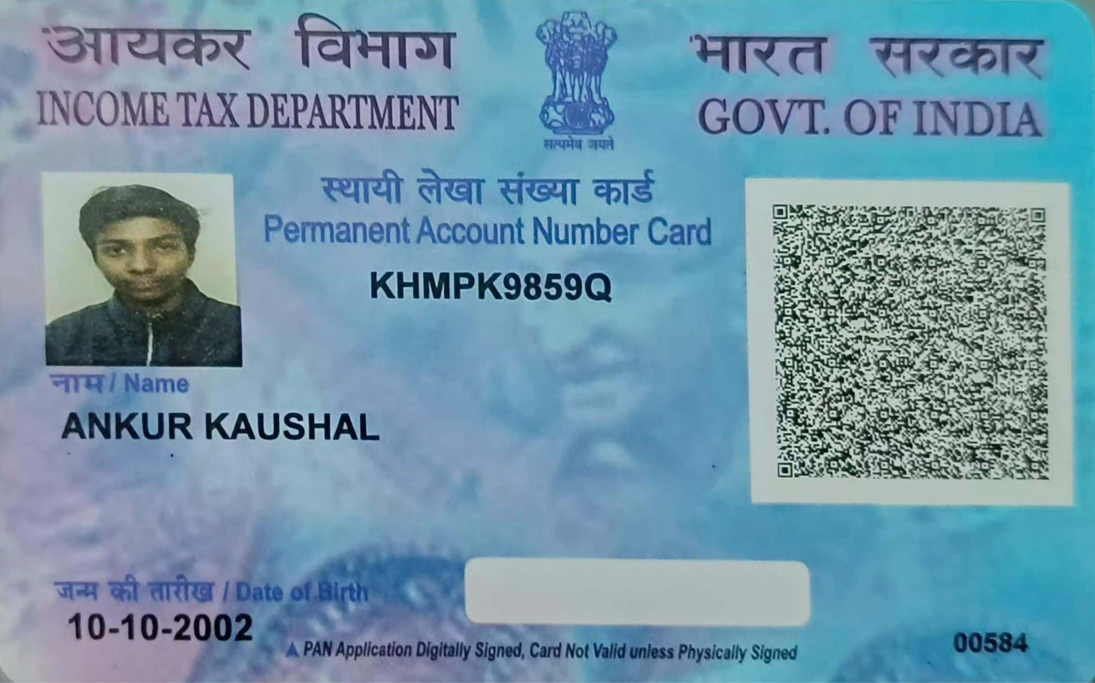

**PAN and Aadhar link Confirmation**  
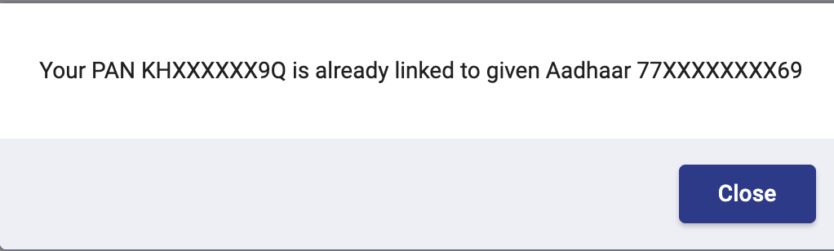

**Permanent Address Proof**

